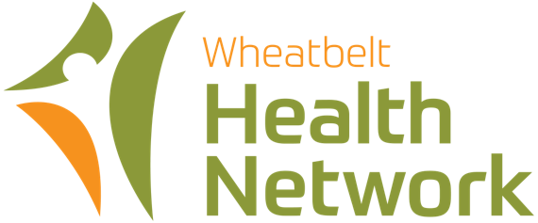

Chief Executive Officer
Part Time Salary Package $146,852 including vehicle and
superannuation plus packaging
- Rare WA health leadership opportunity
- Leading not-for-profit organisation
- Make a positive impact on the health of regional communities.
The Organisation
The Wheatbelt Health Network Inc (WHN) is a leading not-for-profit organisation that delivers integrated primary care, funded health programs, Aboriginal health, and social and community projects supporting rural communities. Three service delivery hubs operate in Northam and Narrogin.
The Wheatbelt Health Centre in Northam is the organisation’s headquarters, in the heart of the historic and scenic Avon Valley, 98 kilometres from Perth.
The Opportunity
A special CEO leadership opportunity exists for an exceptional executive/senior manager to lead operations in line with legislative and regulatory requirements. Working collaboratively with a professionally diverse board, you will use your skills in leadership; recruitment and personnel management; and finance to refine existing services whilst seeking other business development opportunities.
Interested persons can obtain an Information Package & Selection Criteria by contacting Mike FitzGerald on 0419907443; by email at mike@fitzgeraldstrategies.com.au; or by downloading the document at
https://www.fitzgeraldstrategies.com.au/local-government-job-vacancies/
Applications including a Curriculum Vitae and statement addressing the Selection Criteria and three current referees should reach the undersigned in electronic format emailed to mike@fitzgeraldstrategies.com.au by the close of business Monday 26 August 2024.

For a confidential chat contact Dr Marian Rae, Deputy Chair, 0427 412 778.
Mike Fitz Gerald
PRINCIPAL
Fitz Gerald Strategies
Licensed Employment Agent (Lic No EA2423)

